IOT Based Smart Irrigation System using Reinforcement Learning

Worldwide all countries economy and progress heavily dependent of agriculture and this agriculture crops must be irrigated properly by giving suitable amount of waters and essential ingredients but it’s difficult to monitor and provide required essentials to crop manually so governments are coming up with new ideas such as IOT and UAV (unmanned aerial vehicles) based technologies to monitor crop. This IOT and UAV will inform farmer about required ingredients and amount of water. IOT and UAV required manual farmer to provide water and other ingredients which is hard and time consuming process.

To overcome from above issues we are combining IOT and Reinforcement Learning (RL) algorithm where IOT will sense current field condition and then input to RL algorithm which will predict weather field is Dry, Wet, Very Dry and Very wet. Based on predicted values IOT will switch ON or OFF water and can provide other ingridients. By employing RL algorithm manual process can be avoided and IOT will give required amount of water to crop.

Reinforcement learning algorithms takes decision using Environment, Agent and Actions. Here Current Field Condition is the Environment and Agent will always monitor environment and call Action function to predict field condition. If RL manages to predict correct value then it will get rewarded else get penalised. To earned rewards RL will predict accurate values and prediction error will be avoided.

In below screen we are showing code for AGENT and Environment

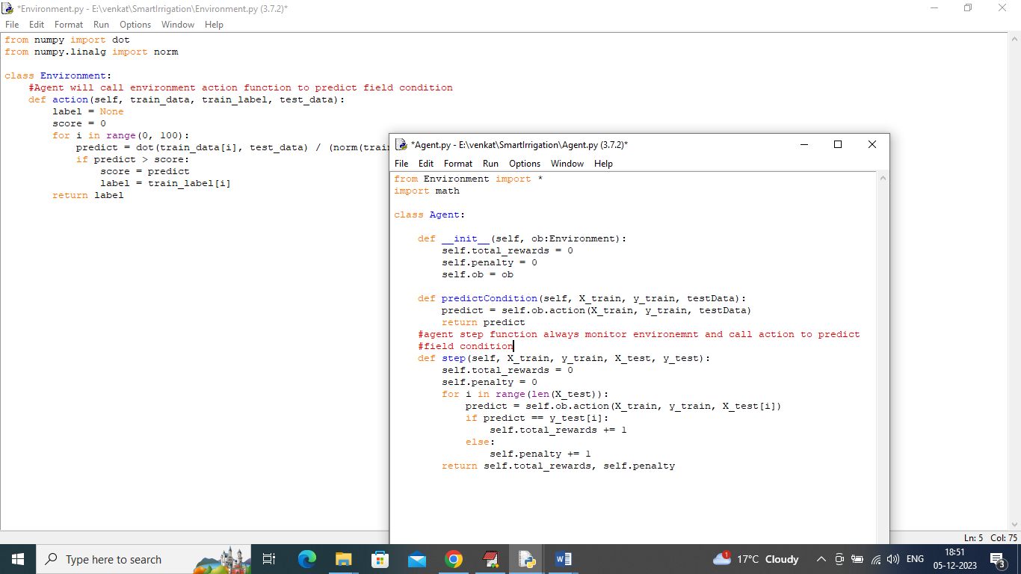

In above screen Agent and Environment will operate on agriculture field data to predict status.

To predict field statues we are training Reinforcement Learning algorithm with below dataset

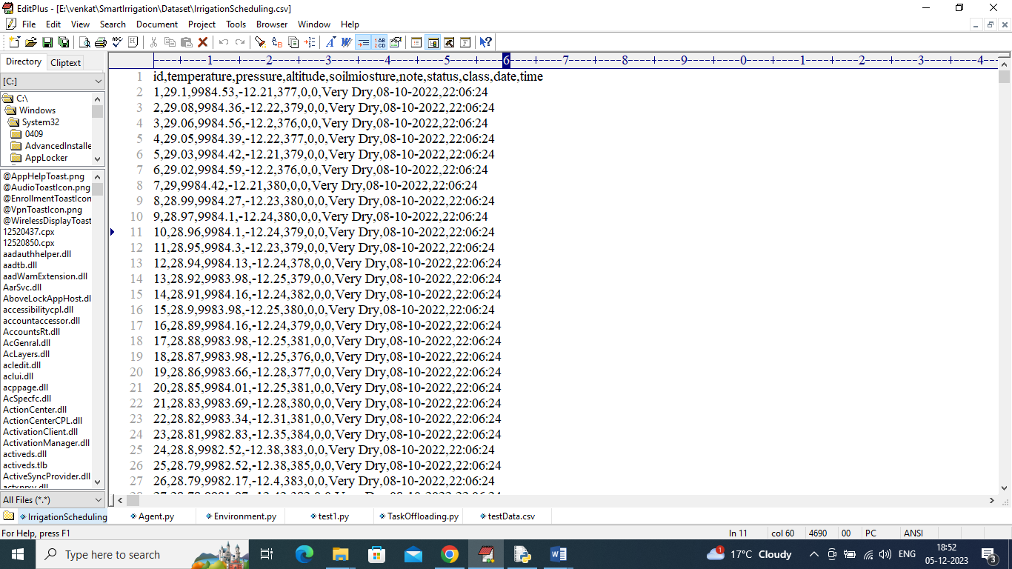

In above dataset screen first row represents dataset column names and remaining rows represents dataset values and dataset contains field temperature, pressure, status and other values. So by using above dataset will train RL algorithm and calculate rewards and penalties.

To implement this project we have designed following modules

1. Upload Irrigation Dataset: using this module we will upload dataset to application and then extract class labels and features available in dataset
2. Preprocess Dataset: using this module will remove missing values and then normalized all values using Standard Scaler algorithm
3. Dataset Train & Test Split: split dataset into train and test where RL get trained on 80% dataset and then perform prediction on 20% test data and RL will get rewards for all correct prediction
4. Train Reinforcement Learning Algorithm: using this module RL will get trained on 80% dataset and evaluate performance on 20% test data
5. Rewards & Penalty Graph: will plot rewards and penalties graph earned by RL algorithm
6. Predict Irrigation Status: upload test data and then RL will predict field condition as Wet, DRY etc.

SCREEN SHOTS

To run project double click on ‘run.bat’ file to get below screen

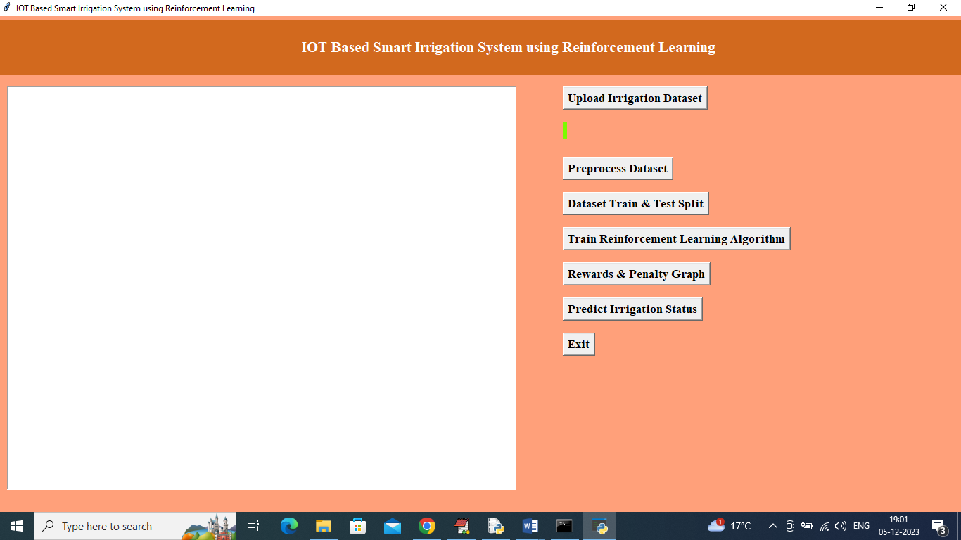

In above screen click on ‘Upload Irrigation Dataset’ button to upload dataset and get below output

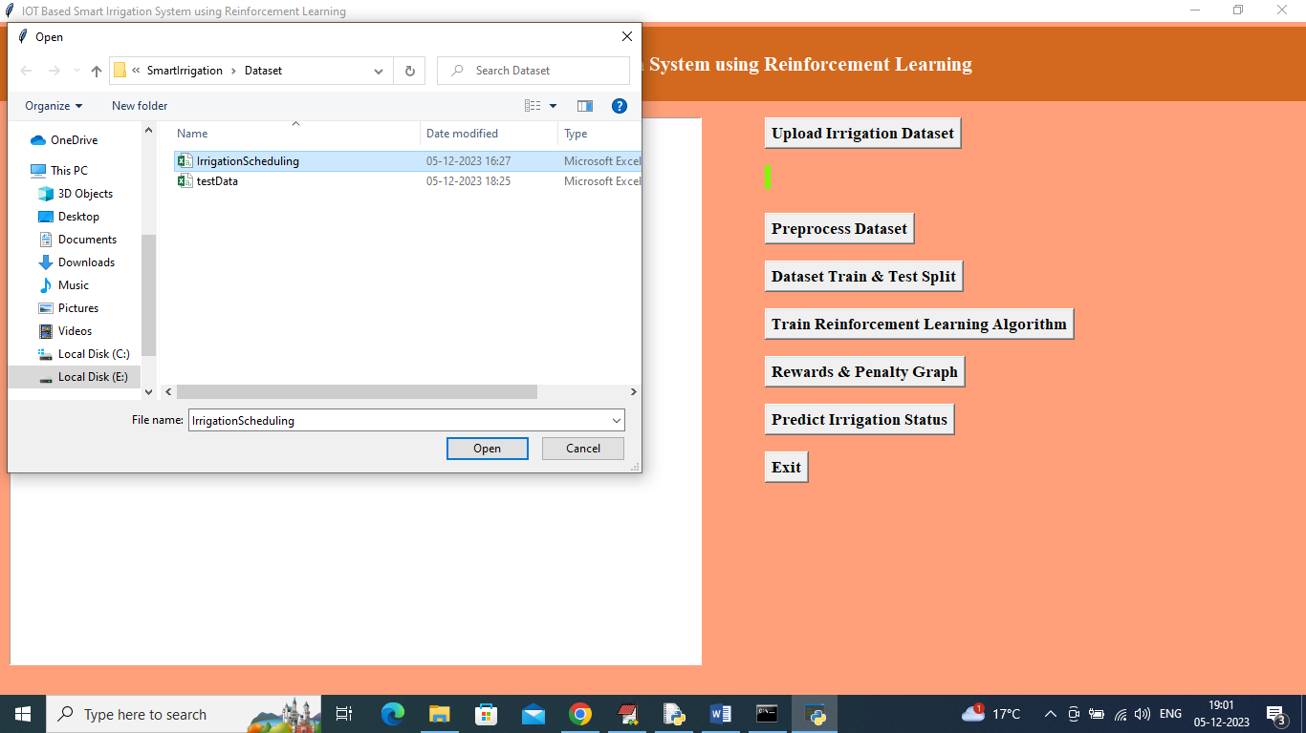

In above screen selecting and uploading Irrigation dataset and then click on ‘Open’ button to load dataset and get below output

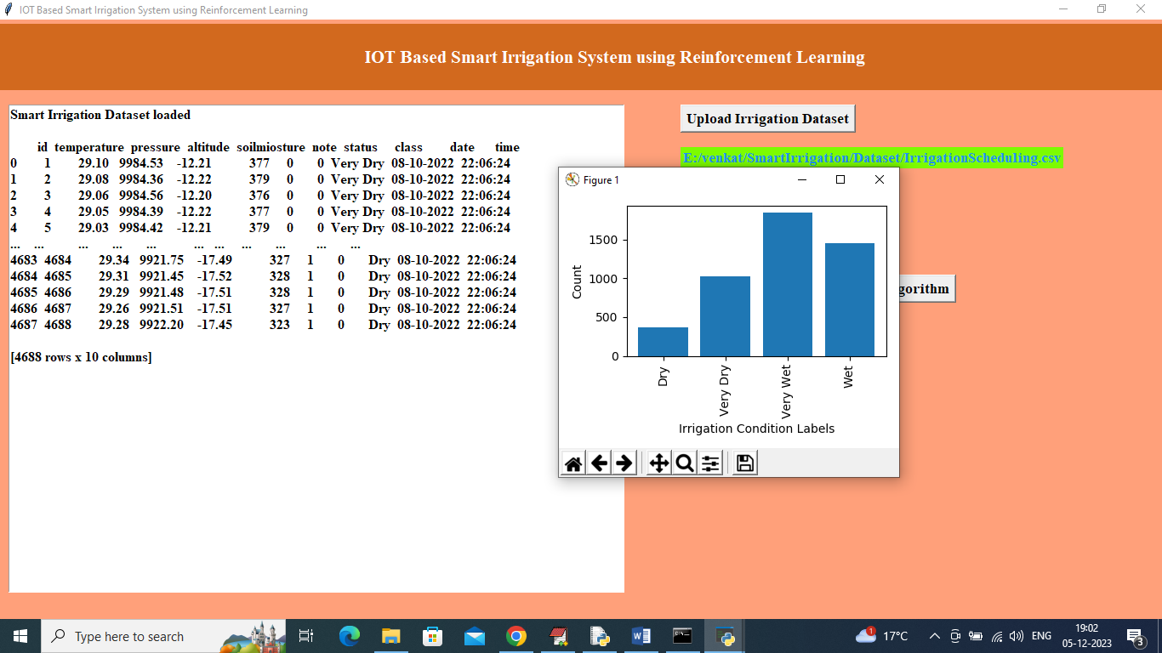

In above screen dataset loaded and in graph can see types of field condition where x-axis represents Condition and y-axis represents number of instances that condition hold in dataset and now close above graph and then click on “Pre-process Dataset” button to clean and normalized dataset and get below output

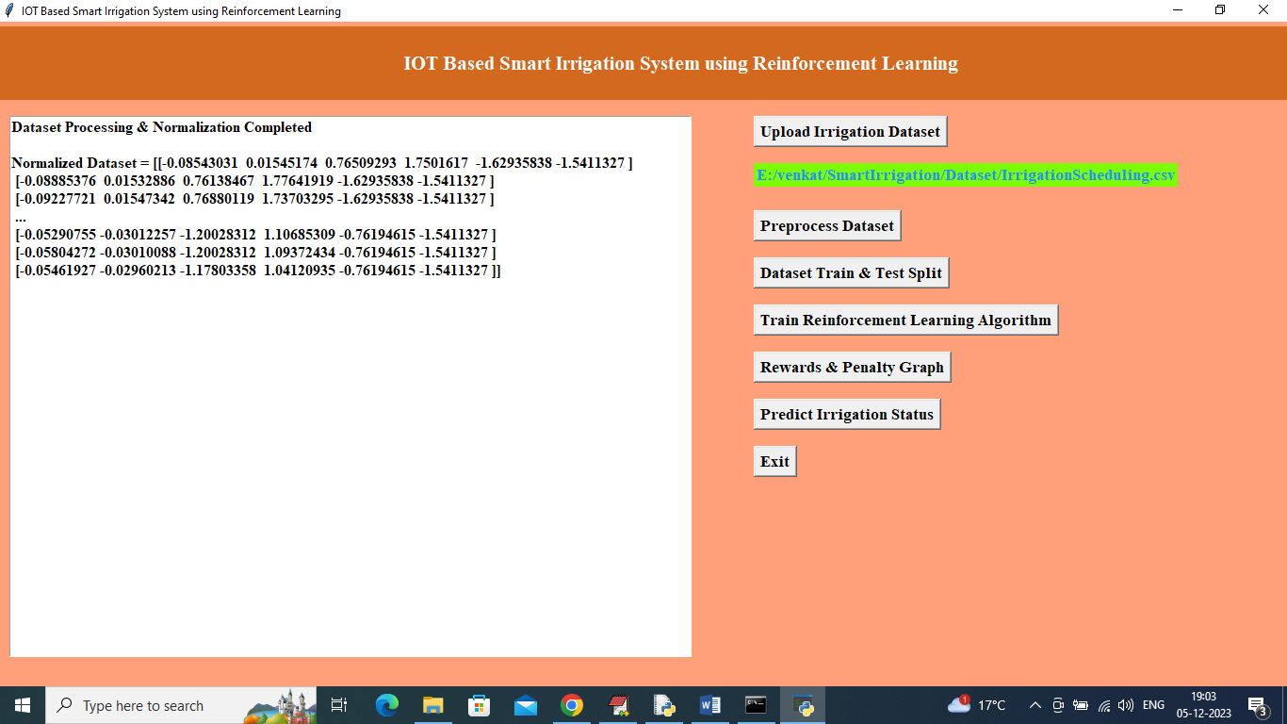

In above screen can see normalized dataset values and then click on ‘Dataset Train & Test Split’ button to split dataset into train and test and then will get below output

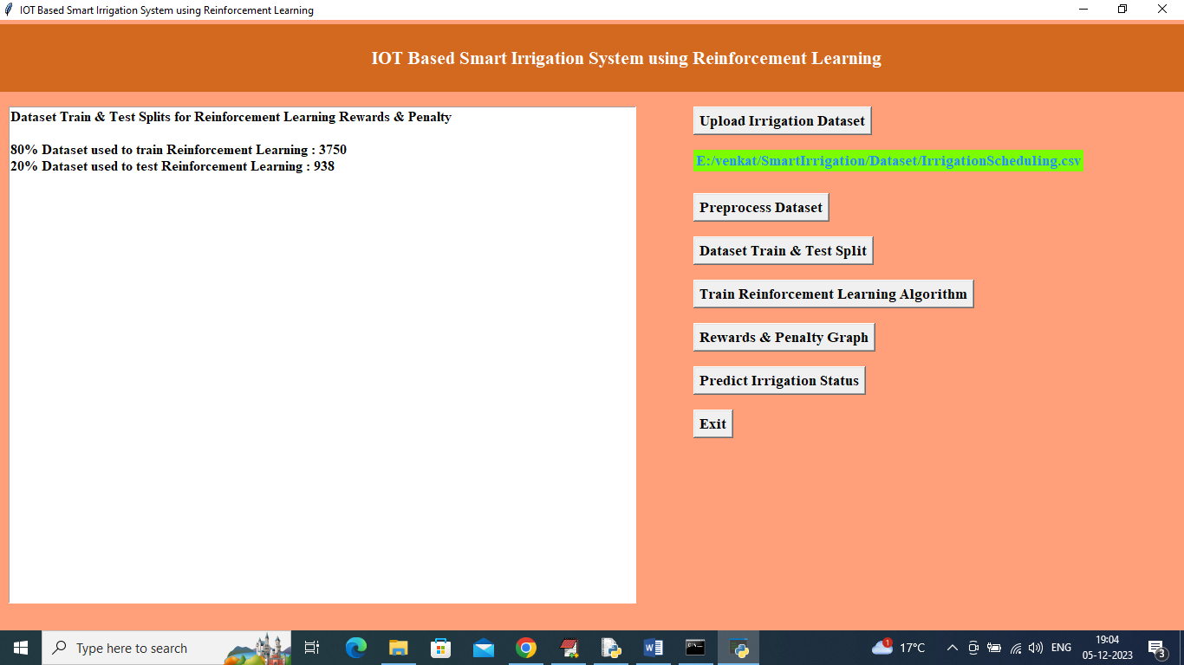

In above screen can see train and test size and now click on ‘Train Reinforcement Learning Algorithm’ button to train RL and get below output

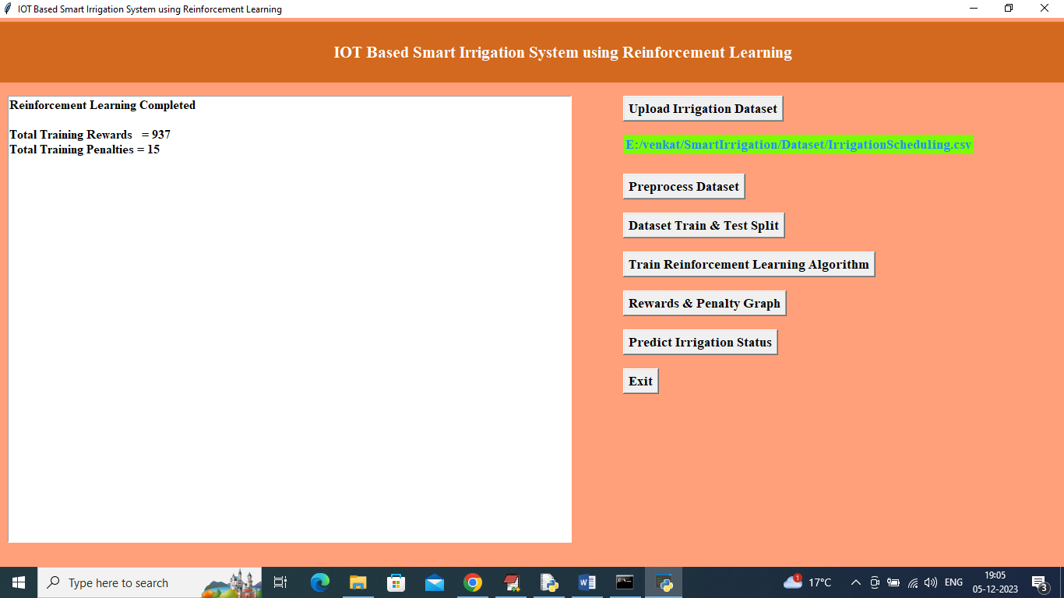

In above screen can see number of rewards and penalties earned by RL by predicting on test data and can see penalties are very few compared to rewards so RL can predict field condition accurately and now click on Rewards & penalty Graph’ to get below graph

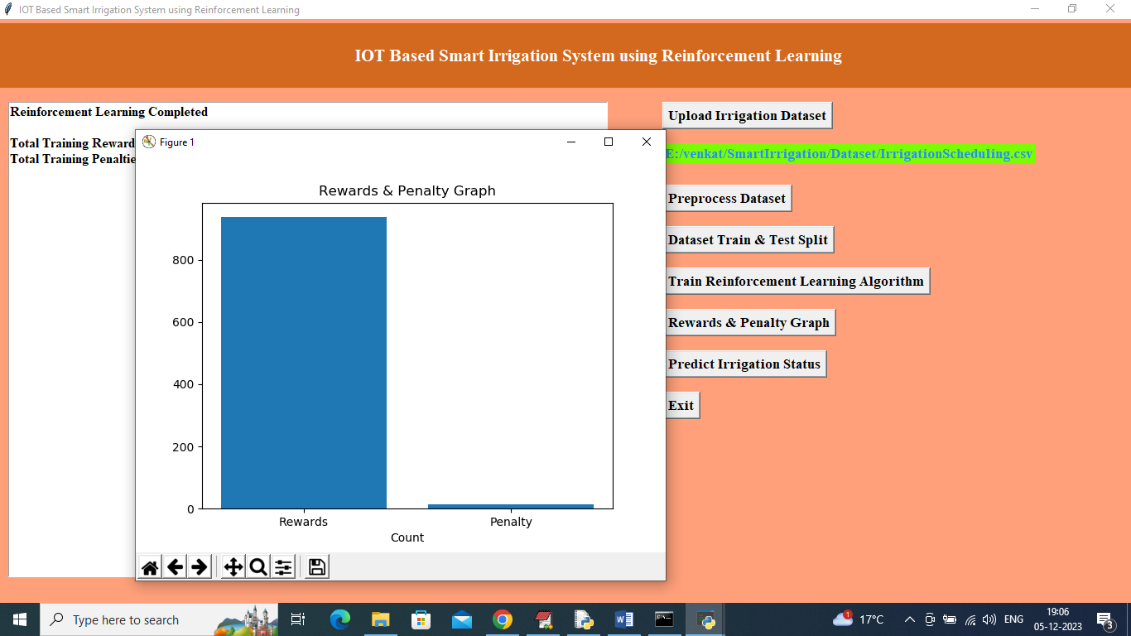

In above graph x-axis represents earned type and y-axis represents values and can see Rewards are more compare to Penalties and now close above graph and then click on ‘Predict Irrigation Status’ button to upload test data and get prediction

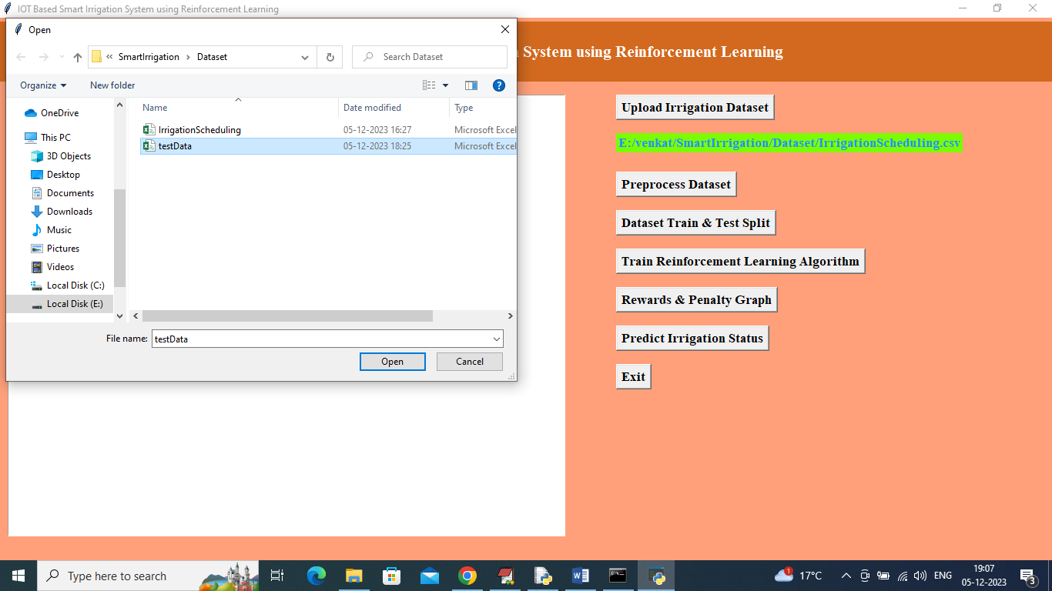

In above screen uploading test data and then click on ‘Open’ button to load test data and get below prediction

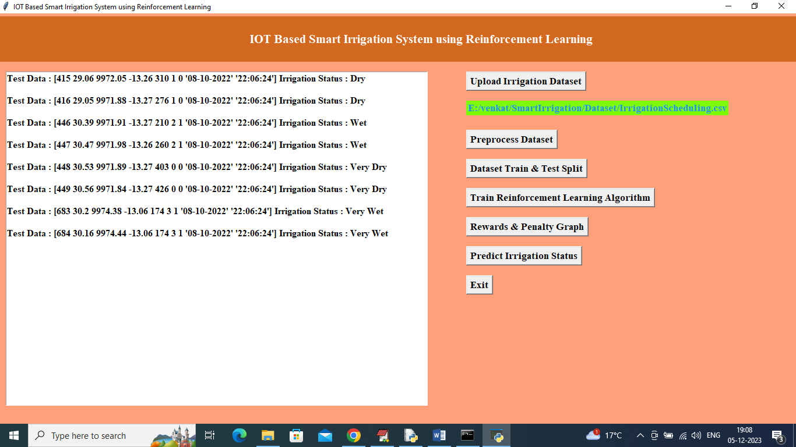

In above screen in square bracket can see test data and after square bracket can see predicted field condition as Wet, Dry, Very Wet or Very Dry and based on above prediction IOT will give water to crop